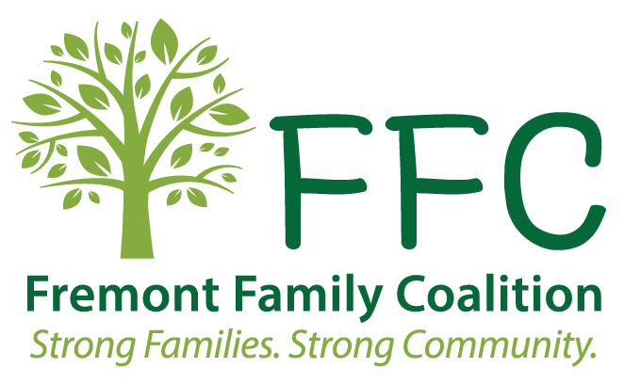
Fremont Family Coalition
Community Response

Request and Authorization for Release of Confidential Information

I, ______________________DOB____________ hereby authorize the reciprocal release of information contained in these records between the Fremont Family Coalition and its partnering agencies.
The purpose for such disclosure is:
Assessment, services and case management for connections to community resources
______________________________________________________________________
This consent allows your information to be shared between the Fremont Family Coalition and any partnering agencies that may assist you. See page 2.
I have been provided with the names of the community partners that may assist with helping me reach my goals. Initials___
I have had the opportunity to review the list and cross off the agencies that I do not want to share my information with. Initials ___

Witnessed by Signature

Date Witnessed Date Signed

Phone number:____________________________ Parent Signature (for youth under the age of 19)

Date Signed

Without expressed revocation, this consent will expire one year from date of signature

Community Response Advocates
Dodge County Head Start
Lutheran Family Services
Pathfinder Support Services
Three Rivers Public Health Department

City of Fremont- Department of Utilities
Dodge County Attorney’s Office
Dodge County Probation
ESU2-University of NE
Fremont Public Schools
Fremont Housing Authority
Good Neighbor Community Health Center
Methodist Fremont Health
Nebraska Department of Health and Human Services
OPPD
NPPD
Rebuilding Together
The Bridge
Northeastern Community Action Partners / WIC
Salvation Army
Mosaic
North Star
Duet
Fremont Transit Program
Uniquely Yours Stability Support
Care Corps LifeHouse
Dodge County Sheriff’s Dept.
Saunders County CR
Central Plains
FindHelp

Service Providers/Informal Supports
Therapist Name: ________________________
Contact info: ________________________

Employer: _________________________
Contact info: ________________________

Landlord: _______________ __
Contact info: ________________________

Utility Department: _______________ __
Contact info: ________________________

School: ______________________________
Contact info: ________________________

*Family/ Youth can choose to add or delete those they wish to share information with

